Final Project Report ECE-111
Name: Jasper Huang
PID: A17796149

What is SHA 256 and Bitcoin Hashing?
SHA-256 and bitcoin hashing are both hash algorithms used to create a code to check if the data integrity is violated during the process of transferring or to save and compare password during authentication process. In the case of Bitcoin, since all block are connected using this algorithm into a chain (blockchain), whenever there’s a slight change to any part of the chain, every value will change accordingly, giving all the owner to identify the integrity of each block data and make sure that there’s no change to the data itself through cross checking of different block, checking if a malicious user has modified the block.

What is the Algorithm?
The algorithm uses constant right rotation of the value and message extension to output the hashed value in the same length. Each bit is grouped and processed multiple times using right rotation and combined with bits around, which ultimately creates a hash valued that can’t reversely calculate the original value, however, the hash value will always be the same for each input, giving user the ability to identify if there’s change in the original data.

Simulations
simplified_sha256
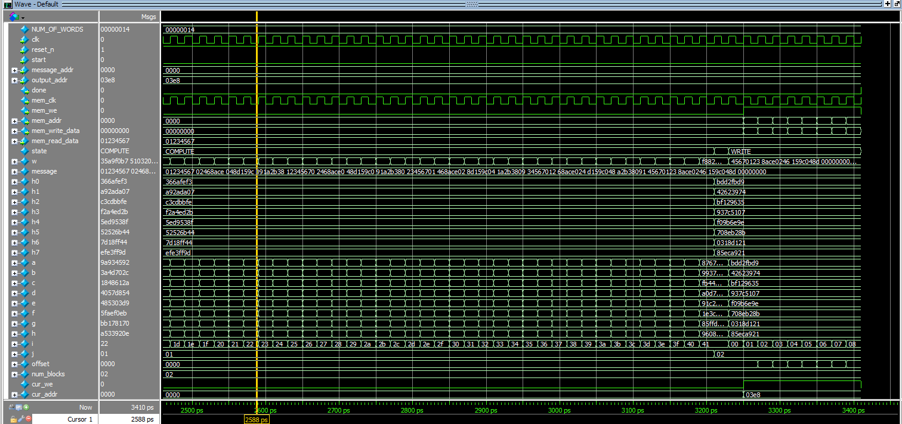
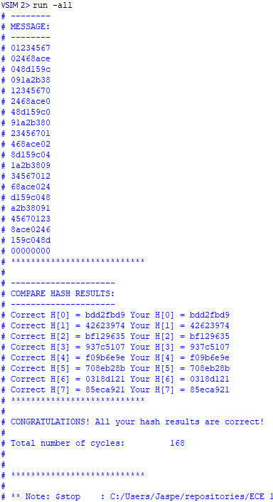

bitcoin_hash
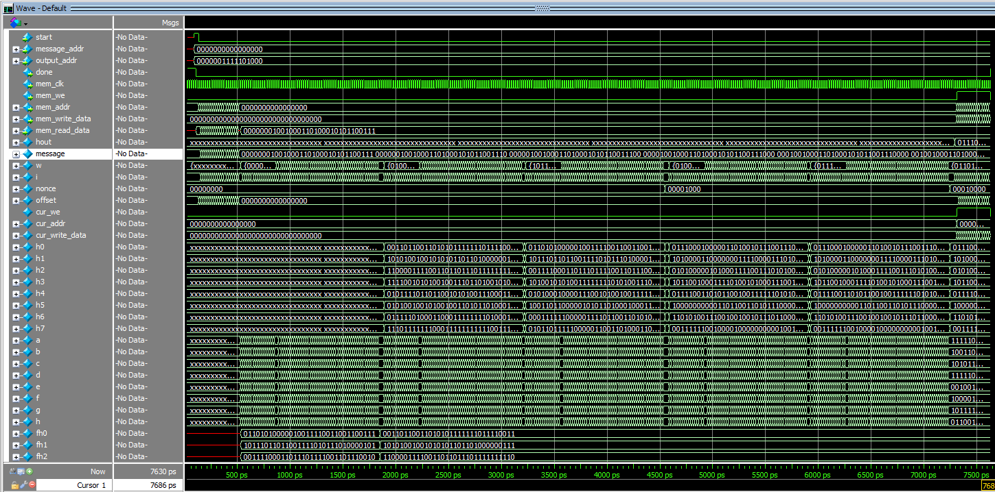
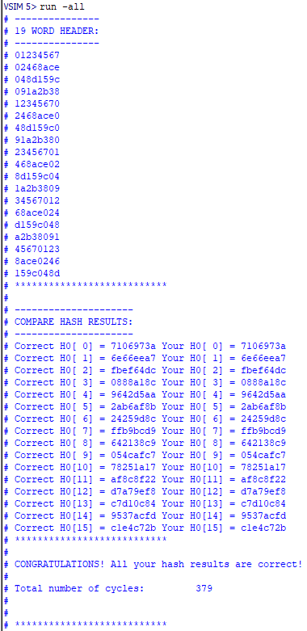

Resource Usage Summary

simplified_sha256
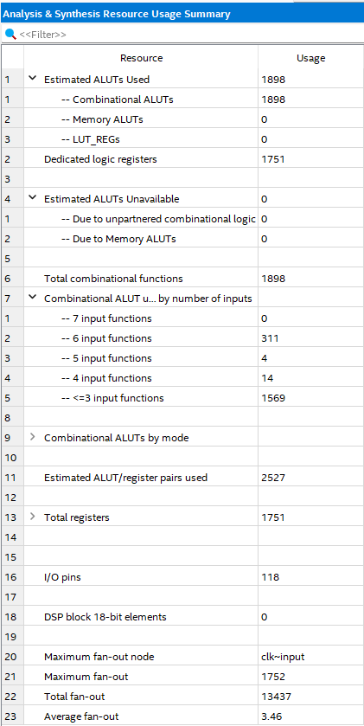

bitcoin_hash
